--task 1

CREATE DATABASE SALES_DB;

CREATE SCHEMA SALES_DB.RAW_SCHEMA;

CREATE FILE FORMAT SALES_DB.RAW_SCHEMA.csv_format

TYPE='CSV'

FIELD_OPTIONALLY_ENCLOSED_BY='"'

SKIP_HEADER=1;

CREATE STAGE SALES_DB.RAW_SCHEMA.sales_stage

FILE_FORMAT = (FORMAT_NAME = 'csv_format');

LIST @SALES_DB.RAW_SCHEMA.sales_stage;

--task 2

CREATE OR REPLACE TABLE SALES_DB.RAW_SCHEMA.sales_raw(

transaction_id STRING,

region STRING,

country STRING,

product STRING,

customer STRING,

sales_rep STRING,

transaction_date STRING,

timestamp VARCHAR(30),

quantity STRING,

unit_price STRING,

total_amount NUMBER,

order_status STRING,

payment_method STRING,

product_details VARIANT,

customer_info VARIANT

);

COPY INTO SALES_DB.RAW_SCHEMA.sales_raw

FROM @sales_stage/sales_data_dirty.csv

FILE_FORMAT=(FORMAT_NAME = 'csv_format')

ON_ERROR='CONTINUE';

--task 3

SELECT COUNT(*) AS TOTAL,COUNT(DISTINCT transaction_id) AS DIST_ID FROM SALES_DB.RAW_SCHEMA.sales_raw;

SELECT COUNT(*) FROM SALES_DB.RAW_SCHEMA.sales_raw

WHERE TRANSACTION_ID IS NULL OR

UNIT_PRICE IS NULL OR

REGION IS NULL OR

COUNTRY IS NULL OR

PRODUCT IS NULL OR

CUSTOMER IS NULL OR

SALES_REP IS NULL OR

transaction_date IS NULL OR

timestamp IS NULL OR

quantity IS NULL OR

total_amount IS NULL OR

order_status IS NULL OR

payment_method IS NULL OR

product_details IS NULL OR

customer_info IS NULL;

select count (*) as negative_values from SALES_DB.RAW_SCHEMA.sales_raw

where try_to_number(quantity)<0 or

try_to_number(total_amount)<0 or

try_to_number(unit_price) <0;

--task 4 and 5

create schema sales_db.clean_schema;

CREATE OR REPLACE TABLE SALES_DB.CLEAN_SCHEMA.SALES_CLEAN AS

SELECT

transaction_id,

region,

country,

product,

customer,

sales_rep,

TRY_TO_DATE(transaction_date, 'DD-MM-YYYY') AS transaction_date,

TRY_TO_TIMESTAMP_NTZ(timestamp, 'DD-MM-YYYY HH24:MI') AS transaction_ts,

CASE

WHEN TRY_TO_NUMBER(quantity) < 0 THEN 0

WHEN TRY_TO_NUMBER(quantity) IS NULL THEN 0

ELSE TRY_TO_NUMBER(quantity)

END AS quantity,

CASE

WHEN TRY_TO_NUMBER(unit_price) < 0 THEN 0

ELSE TRY_TO_NUMBER(unit_price)

END AS unit_price,

CASE

WHEN TRY_TO_NUMBER(total_amount) < 0 THEN 0

ELSE TRY_TO_NUMBER(total_amount)

END AS total_amount,

order_status,

payment_method,

product_details:category::STRING AS product_category,

product_details:subcategory::STRING AS product_subcategory,

product_details:brand::STRING AS product_brand,

product_details:specs::STRING AS product_specs,

CASE

WHEN TRY_TO_NUMBER(product_details:ratings::STRING) < 0 THEN 0

ELSE TRY_TO_NUMBER(product_details:ratings::STRING)

END AS product_ratings,

customer_info:segment::STRING AS customer_segment,

customer_info:demographics::STRING AS customer_demographics,

customer_info:preferences::STRING AS customer_preferences

FROM SALES_DB.RAW_SCHEMA.sales_raw;

DELETE FROM SALES_DB.CLEAN_SCHEMA.SALES_CLEAN

WHERE TRANSACTION_ID IS NULL OR

QUANTITY IS NULL OR

TOTAL_AMOUNT IS NULL OR

UNIT_PRICE IS NULL OR

UNIT_PRICE=0 OR

QUANTITY=0 OR

customer_segment IS NULL OR

product_brand IS NULL;

SELECT * FROM SALES_DB.CLEAN_SCHEMA.SALES_CLEAN;

--task 6

ALTER TABLE SALES_DB.CLEAN_SCHEMA.SALES_CLEAN

ADD COLUMN PROFIT_MARGIN NUMBER;

ALTER TABLE SALES_DB.CLEAN_SCHEMA.SALES_CLEAN

ADD COLUMN SALES_QUARTER STRING;

UPDATE SALES_DB.CLEAN_SCHEMA.SALES_CLEAN

SET profit_margin = total_amount - (unit_price * quantity),

sales_quarter = 'Q' ||CAST(EXTRACT(QUARTER FROM TRANSACTION_DATE)AS STRING)|| '-' || TO_CHAR(transaction_date, 'YYYY');

select * from clean_schema.sales_clean;

--task 7

CREATE OR REPLACE TABLE SALES_DB.CLEAN_SCHEMA.DIM_REGION AS

SELECT DISTINCT TRIM(region) AS REGIONS, country FROM SALES_DB.CLEAN_SCHEMA.SALES_CLEAN;

CREATE OR REPLACE TABLE SALES_DB.CLEAN_SCHEMA.DIM_PRODUCT AS

SELECT DISTINCT product, product_category, product_subcategory, product_brand FROM SALES_DB.CLEAN_SCHEMA.SALES_CLEAN;

CREATE OR REPLACE TABLE SALES_DB.CLEAN_SCHEMA.DIM_CUSTOMER AS

SELECT DISTINCT customer, customer_segment, customer_demographics, customer_preferences FROM SALES_DB.CLEAN_SCHEMA.SALES_CLEAN;

CREATE OR REPLACE TABLE SALES_DB.CLEAN_SCHEMA.FACT_SALES AS

SELECT

transaction_id,

transaction_date,

transaction_ts,

customer,

product,

TRIM(region) AS REGIONS,

country,

sales_rep,

quantity,

unit_price,

total_amount,

profit_margin,

sales_quarter,

order_status,

payment_method,

product_ratings

FROM SALES_DB.CLEAN_SCHEMA.SALES_CLEAN;

SELECT * FROM SALES_DB.CLEAN_SCHEMA.FACT_SALES;

SELECT * FROM SALES_DB.CLEAN_SCHEMA.DIM_CUSTOMER;

SELECT * FROM SALES_DB.CLEAN_SCHEMA.DIM_PRODUCT;

SELECT * FROM SALES_DB.CLEAN_SCHEMA.DIM_REGION;

--task 8

SELECT REGIONS,SUM(TOTAL_AMOUNT) AS TOTAL_SALES FROM SALES_DB.CLEAN_SCHEMA.FACT_SALES

GROUP BY REGIONS

ORDER BY TOTAL_SALES DESC;

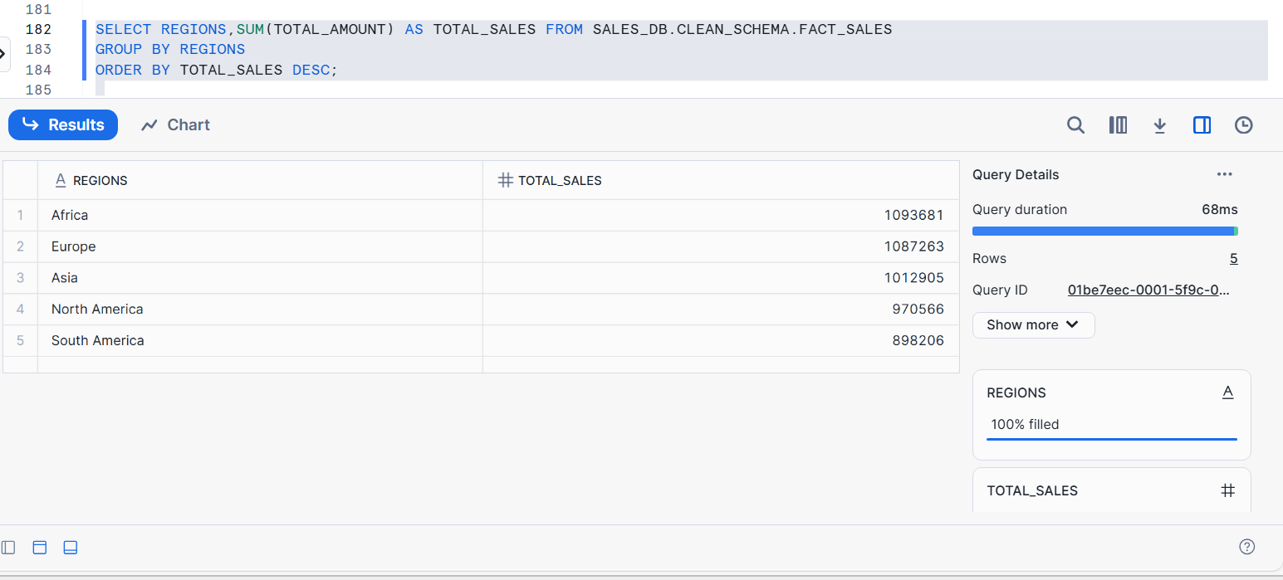

SELECT customer_segment, COUNT(*) AS transactions, SUM(total_amount) AS total_sales

FROM SALES_DB.CLEAN_SCHEMA.SALES_CLEAN

GROUP BY customer_segment

ORDER BY total_sales DESC;

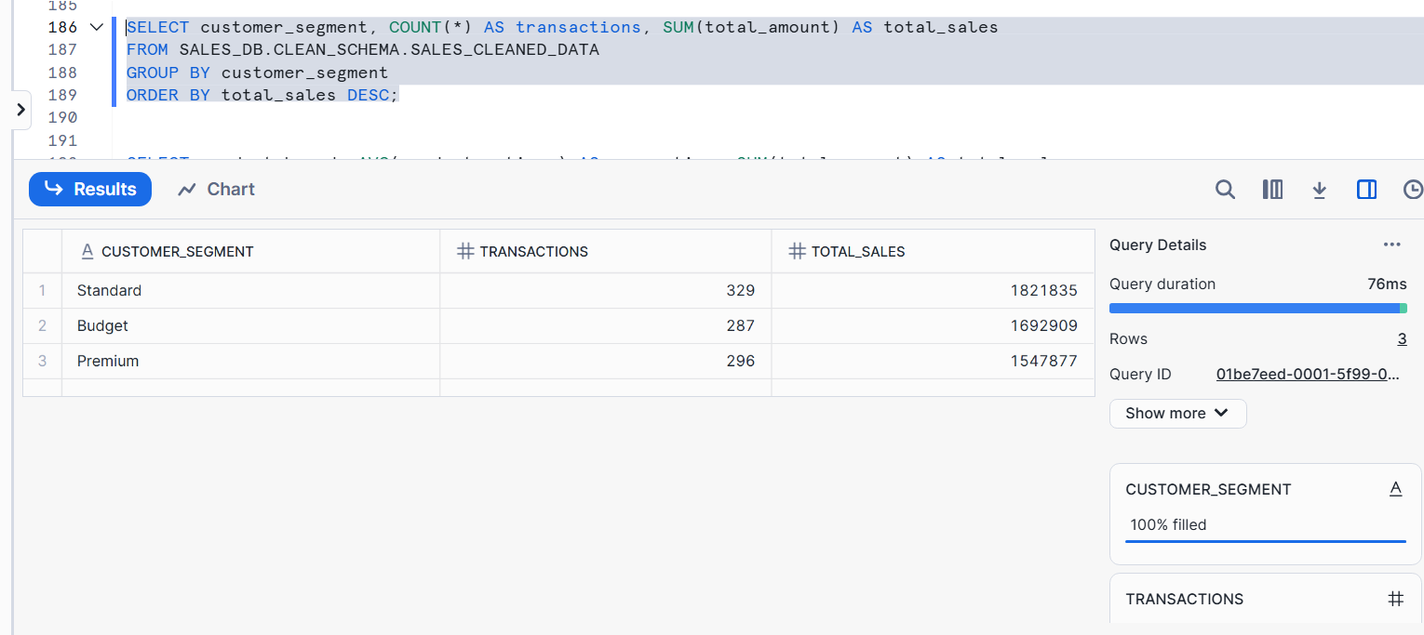

SELECT product_brand, AVG(product_ratings) AS avg_rating, SUM(total_amount) AS total_sales,

ROUND((AVG(product_ratings)*COUNT(*))/100) AS rating_to_sales_ratio

FROM SALES_DB.CLEAN_SCHEMA.SALES_CLEAN

GROUP BY product_brand

ORDER BY rating_to_sales_ratio DESC;

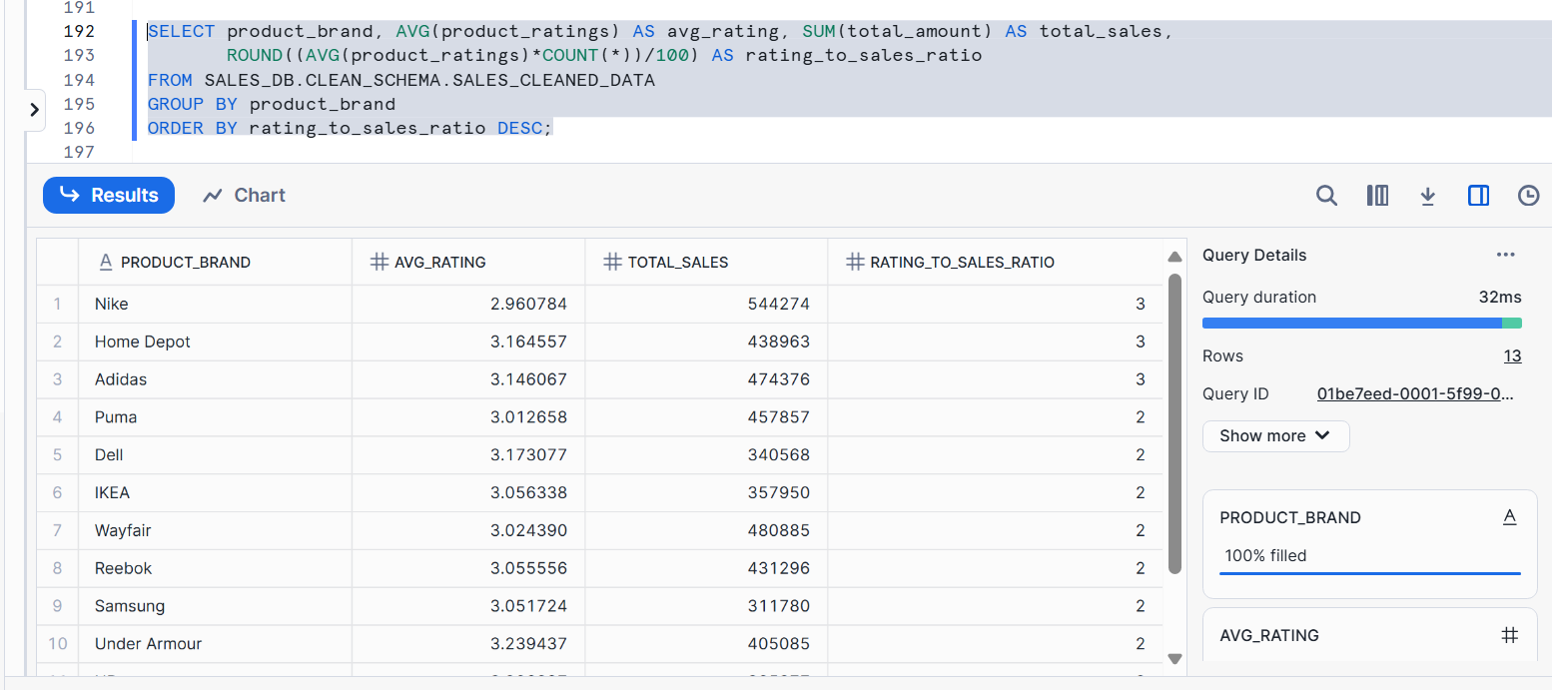

SELECT order_status, COUNT(*) AS order_count

FROM SALES_DB.CLEAN_SCHEMA.FACT_SALES

GROUP BY order_status;

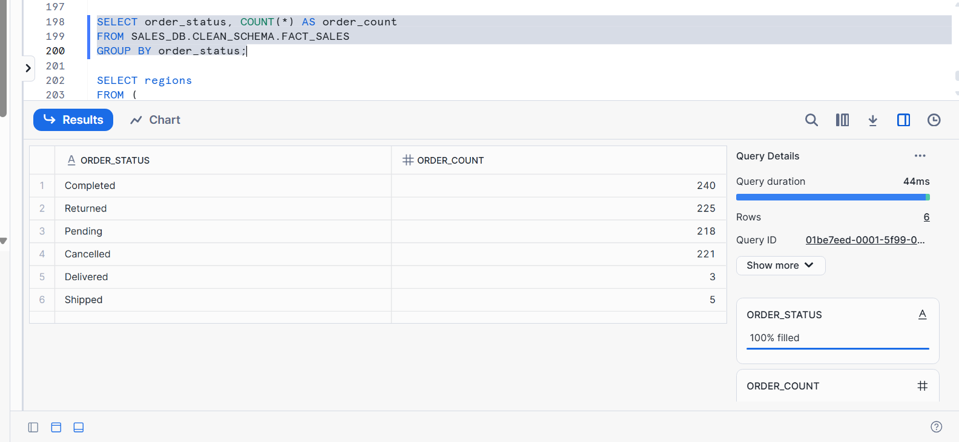

SELECT regions

FROM (

SELECT regions, SUM(total_amount) AS total_sales

FROM SALES_DB.CLEAN_SCHEMA.FACT_SALES

GROUP BY regions

ORDER BY total_sales DESC

LIMIT 1

);

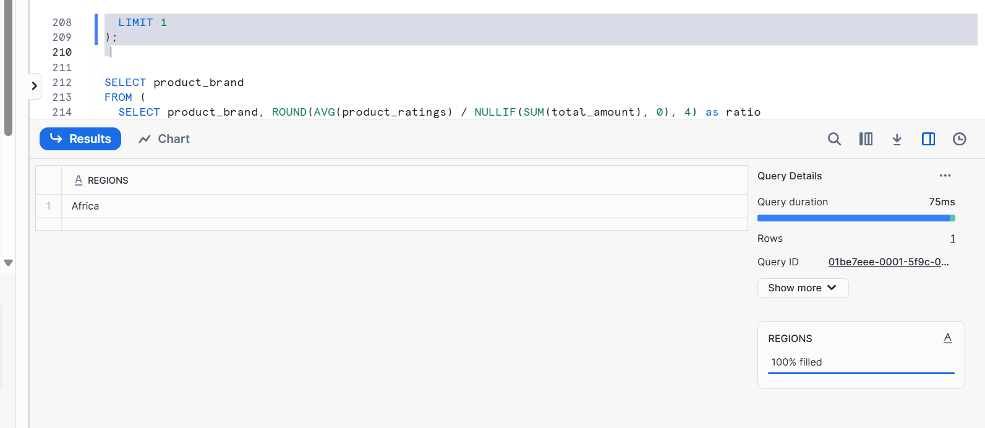

SELECT product_brand

FROM (

SELECT product_brand, ROUND((AVG(product_ratings / NULLIF(SUM(total_amount), 0), 4))) as ratio

FROM SALES_DB.CLEAN_SCHEMA.DIM_PRODUCT

GROUP BY product_brand

ORDER BY ratio DESC

LIMIT 1

);

